**4-4-2 Formation Guide**

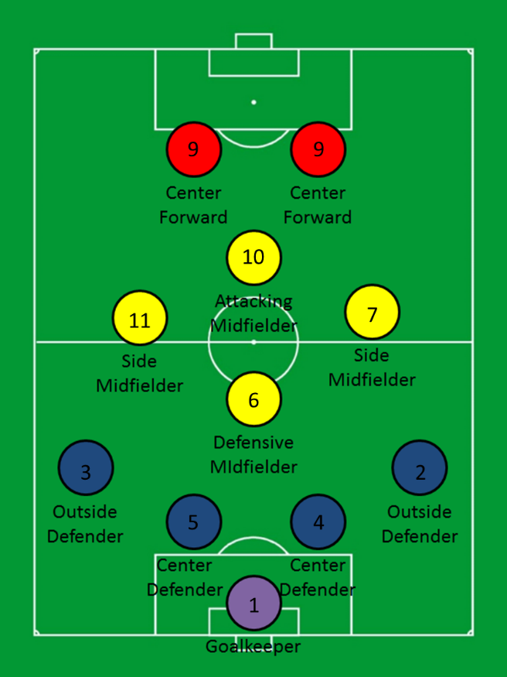 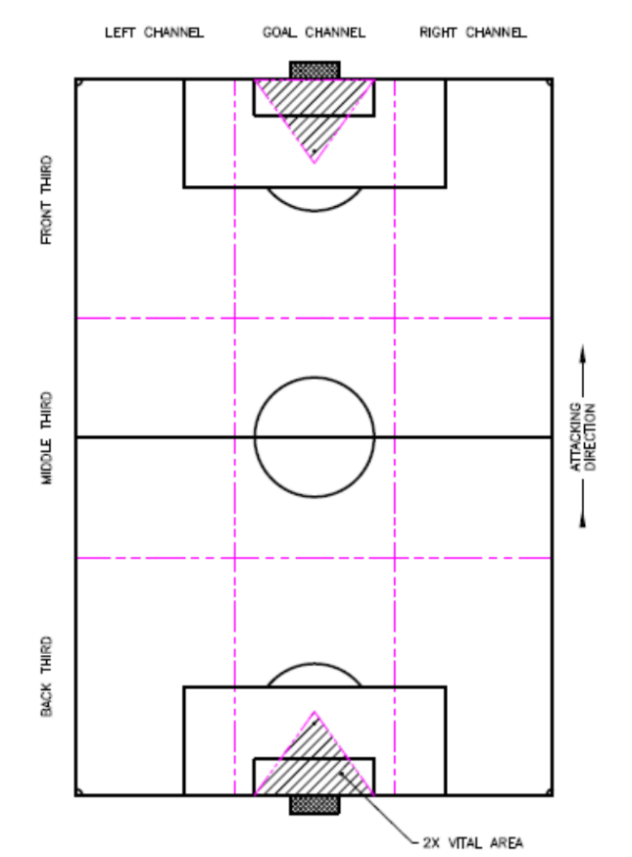

**1) Forwards (# 9s) during the run of play:**

**On offense:**

• Our weak side forward gets high to the opponent’s line of defense (to stretch the field holding their line of defense high so that we have room underneath to work on offense)---take as much space as they will give you; get as high as our opponent’s deepest defender so that you are “on sides”.

• Our weak side forward will crash the nearside goalpost when the ball is wide.

• Our strong side forward checks to the ball; get open to space in order to provide a passing option.

• Both forwards should try to stay at least 10 yards apart working together.

**On defense:**

• Our weak side forward cuts passing lanes.

• Our strong side forward attacks the ball to become the first defender at our chosen line of confrontation (low, medium, high pressure);

• Close down: quick, slow, sideways, low, shepherd (steer) wide in all parts of the field. Deny the long/penetrating pass.

**2) Outside Mids (# 7 & 11) during the run of play:**

**On offense:**

• Our weak side outside mid compresses inside to space providing a passing option; check to the ball.

• Our strong side outside mid gets to the line, open, ready to receive a pass, body open to the ball and to goal.

• Work with Forwards, Outside Backs, and Attacking Mid to move, widen, & penetrate the defense.

**On defense:**

• Our weak side outside mid, if no man up field in your channel, compress inside to a man (mark him, pass him off and then take the next man up field in your area, zonal defending, always shepherd (steer) wide in all parts of the field).

• Our strong side outside mid, the play will be near you so either pressure (quick, slow, sideways, low), or cover (second defender), or mark a man near you cutting the passing lane to the man you are marking.

**3) Attacking Mid (# 10) during the run of play:**

**On offense:**

• Provide overlapping runs with forwards (run wide if our strong side forward is inside, run inside if our wide strong side forward is outside).

• Hold your shape, do not get too wide (let our outside players work the outside channels). Work in the goal channel, check to the ball, support the attack.

• Crash the far-side goalpost when the ball is wide.

**On defense:**

• Recover to mark a man in the goal channel, stay with him and then pass him off to a deeper teammate then sprint up field to take the next man up field in your area; zonal defending; shepherd wide.

• Be the first defender if the first attacker is near you. Don’t just drop into space behind you—step to a man. Do not get even (lateral) with our line of defense. Take a man up field in the goal channel.

• On set pieces, delay the attacking teams kick on fouls & control the area at the top of our box. Provide strong headed & kicked clearances out of the goal channel.

**4) Defending Mid (# 6) during the run of play:**

**On offense:**

• Provide overlapping runs with attacking mid (run wide if our strong side forward is inside, run inside if our wide strong side forward is outside).

• Hold your shape, do not get too wide (let our outside players work the outside channels). Work in the goal channel, check to the ball, support the attack.

• Crash the far-side goalpost when the ball is wide.

**On defense:**

• Do not let the first attacker run straight at the defense. Shepherd dribblers & passes outside the goal channel.

• Be the first defender if the first attacker is near you. Don’t just drop into space behind you—step to a man. Do not get even (lateral) with our line of defense. Take a man up field in the goal channel.

**5) Outside backs (# 2 & 3) during the run of play:**

**On offense:**

• All backs push up quickly once possession is won (create offsides) and compress the field (vertical compression) to about 35 yards from the ball.

• Our weak side outside back compresses inside to create the line of defense with the other backs.

• Our strong side outside back attacks up field (play like a forward but get back on transition); Provide overlapping runs with outside mids (run wide if our outside mid is inside, run inside if our wide outside mid is outside---look for space upfield).

**On defense:**

• All backs drop to create the line of defense.

• Once the line of defense is set, then our weak side back balances and our strong side marks.

• Mark inside, shepherd wide in all parts of the field.

**6) Inside backs (# 4 & 5) during the run of play:**

**On offense:**

• Ensure all backs push up to compress the field (vertical compression) to about 35 yards from the ball.

• After winning the ball, dribble/carry the ball until the opposition closes you. Then pass to penetrate or widen the play.

• On offense or set pieces, if one of the inside backs go up field on attack, call for a fill man (the fill man will usually be an inside mid) so that you have numbers up by one player.

**On defense:**

• Both inside backs hold the goal channel.

• On defense, step up to become the first defender if the first attacker is near you. The other inside back should then get into a cover position behind you (second defender).

• If marking one opponent, sandwich him, faster man behind/goal side of him.

• Always have numbers up by one, mark one step inside (goal side) and one step back (diagonal to your mark).

• Once our line of defense is set, always have one inside back should be slightly retracted behind our line of defense (to collect long balls over the top or through balls).

• Start to organize our defense as soon as the ball crosses the half way line----organize our mids and our backs loudly, start early!!!!!

**7) Keeper (# 1) during the run of play:**

**On offense:**

• Ensure all backs push up to compress the field (vertical compression) to about 35 yards from the ball.

• After winning the ball, run forward to quickly play the ball behind the opposition forwards/midfield with focused ball distribution outside of the goal channel.

• When receiving a backpass, switch the field of play quickly to the opposite back/wing to generate penetration.

**On defense:**

• Always guard the near post and catch or push saves wide of the goal channel.

• Be decisive on your line: Stay on your line unless there is a ball played in the air inside the 6 yd box or a one-on-one break into the box.

• Start to organize our defense as soon as the ball crosses the half way line----organize our mids and our backs loudly, start early!!!!!